Engineering Challenges

#2 Intent Qualification (ML Engineer Intern)

Applicant: Scutaru Stefan-Daniel

Introduction

I chose this problem from among the available options because it seemed to me to be the most interesting and challenging. The first question I asked myself was what “match” really means in this context: not textual similarity, but fulfilling the intent behind the query. That guided all my design decisions.
To run the application locally:
- Clone the repository from GitHub.
- Install the dependencies: pip install -r requirements.txt
- Create a .env file in the root directory and add the API key: ANTHROPIC_API_KEY=ANTHROPIC_API_KEY= {Sent via Email}
- Start the application: streamlit run app.py
The first time you run it, the embeddings model downloads automatically. After that, everything runs locally.

The first interaction with data
The first thing I did was open the companies.jsonl file and figure out what I was working with. Coming from a relational database background, the format took me by surprise. There is no fixed schema; each line is a separate JSON object, and the fields are not consistent across records. Some companies have a “revenue” field, others do not. Some have “secondary_naics” as a list, while others do not have that field at all.
The results of the exploration were clear: 449 companies, with approximately 20% missing values in demographic fields such as number of employees and revenue. The semantic fields (description, industry, products, and target markets) had zero missing values, which confirmed to me that I could build the ranking based on them without worrying about incomplete data. 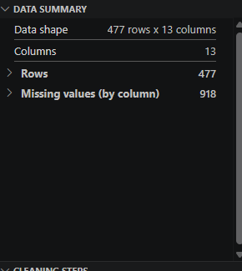
I also checked the business model field, which contained 18 distinct values. Instead of hard-coding them into the prompt, I decided to dynamically extract them from the dataset on each run, so that the list would update automatically if new companies appeared.

Problem Definition and Architecture
Before writing any code, I spent some time thinking about what “match” actually means in this context. The prompt gave a concrete example: a search for “Companies supplying packaging for cosmetics brands” might return cosmetics brands instead of suppliers, because both include the same words. Textual similarity doesn’t capture the role a company plays in an ecosystem.
The prompt presented two baseline approaches. I tried to implement Baseline B, which ranks results based on embedding similarity, but it didn’t work out. The concept was hard to understand, and implementing it correctly turned out to be more complicated than I expected. I decided to go with a simpler and more straightforward solution: structural filtering followed by ranking via an LLM. A call parses the query and extracts the explicit constraints; filters are applied to the dataset; and the remaining companies are sent to Claude, which ranks them by relevance.
- LLM Parser: converts the query into structured filters (JSON), one API call per query
- Structured Filtering: applies the filters to the dataset using Python, instantly and at no cost
- LLM Ranking: sends the filtered candidates to Claude for semantic ranking, one API call
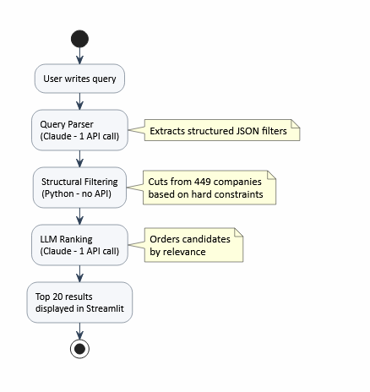
Compared to an embedding-based approach, this solution is simpler to implement, easier to understand, and produces more accurate rankings for complex queries that require reasoning. The additional cost compared to embedding similarity is justified by the superior quality of the results.
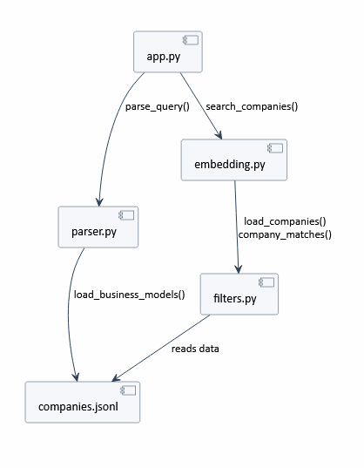

Parser file
The first component I built was the parser: a single call to Claude that converts the query into structured JSON filters.
Writing the prompt was harder than I expected and went through several iterations. The main problem was that the model interpreted numerical operators ambiguously; for example, “more than 100” could mean 100 or 101. I explicitly defined the rules and ran the prompt through Claude, asking it to identify where it was unclear, which led to more consistent output.
During testing, I added new fields as I encountered queries that the initial version couldn’t handle: “country” was converted into an array of ISO codes to support regions like “Scandinavia” or “Europe,” “company_type” to distinguish manufacturers from distributors, and fields for the year of founding for queries asking for recent startups.

Filters file
The filters file applies the JSON produced by the parser directly to the company list. Each company is checked against every active filter, and only companies that satisfy all constraints pass through.
Country filtering now accepts an array of ISO codes instead of a single value, which allows region-based queries to work correctly. When the parser returns a list of codes for "Scandinavia", the filter checks whether the company's country code appears anywhere in that list.
The in_range function handles all numeric constraints uniformly: minimum, maximum, and exact values for employee count, revenue, and year founded. If a company is missing a field that a filter targets, it is excluded. This is a conservative approach that prioritizes precision over recall.
The company_type filter checks the NAICS label directly: if the query asks for manufacturers, the label must contain "manufactur"; for distributors, it must contain "wholesal" or "distribut".
The industry filter is intentionally disabled at this stage. NAICS labels are too technical and specific to match reliably against the general terms users write in queries. That mapping is handled by the LLM ranker instead.

Embedding file
After structural filtering reduces the candidate pool, the remaining companies are sent to Claude in a single API call for ranking. For each company, a short text is built from the name and the first 200 characters of the description. This list, together with the original query, is sent to the model, which returns a JSON array of company indices ordered by relevance.
This approach replaces embedding similarity with direct LLM reasoning. The model understands that a packaging supplier and a cosmetics brand play different roles even when their descriptions share similar vocabulary, which was the core failure of Baseline B.
The trade-off is cost: unlike embeddings that run locally at no cost, this API call adds expense per query. For 449 companies with aggressive structural filtering beforehand, the number of companies sent to ranking is small, so the cost remains acceptable.
The file is named embedding.py for historical reasons, as it originally contained the embedding-based implementation before it was replaced.

Query results

Query 1: "Logistic companies in Romania"
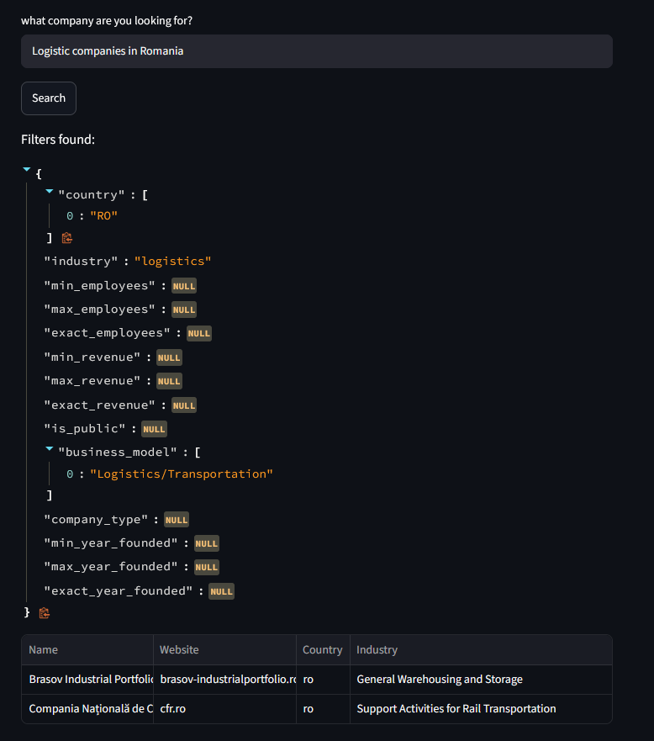

Query 2: "Public software companies with more than 1,000 employees"
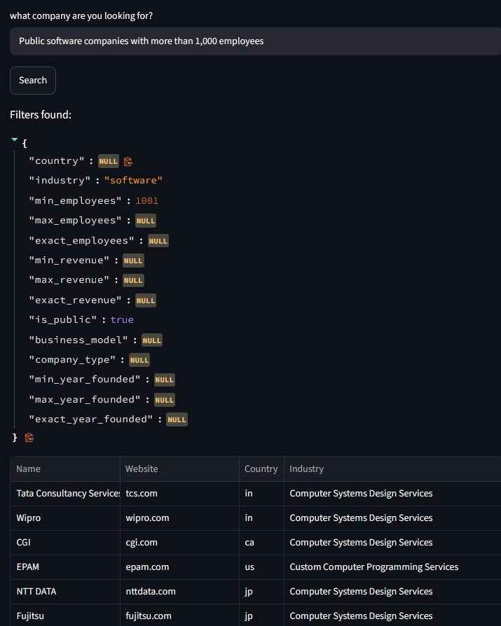
Query 3: "Food and beverage manufacturers in France"
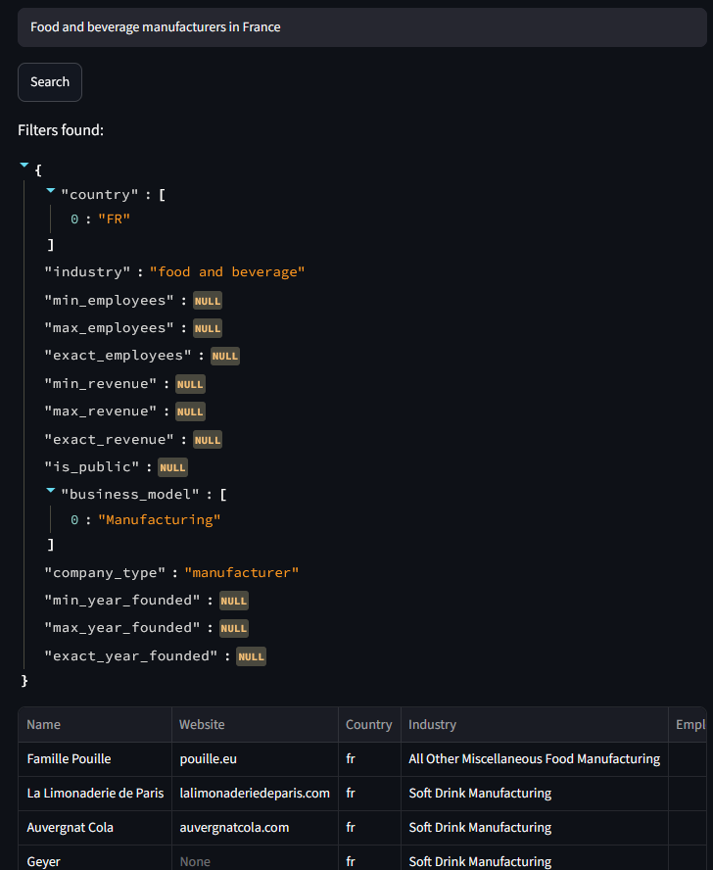

Query 4: "Companies that could supply packaging materials for a direct-to-consumer cosmetics brand"
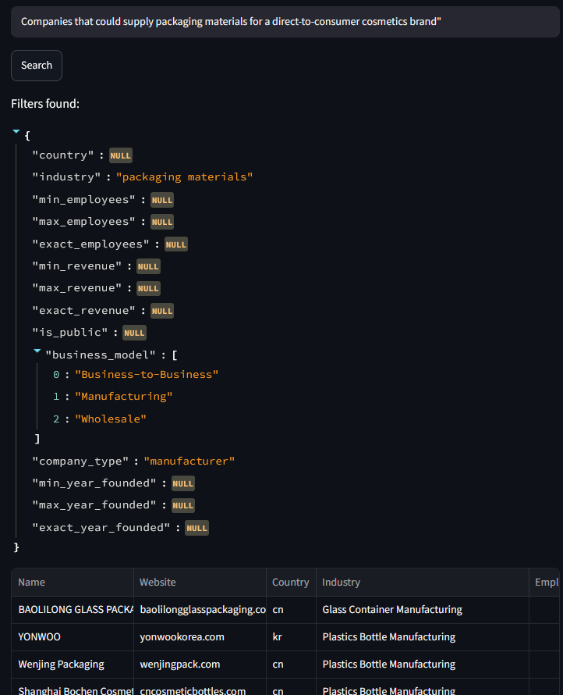

Query 5: "Construction companies in the United States with revenue over $50 million"
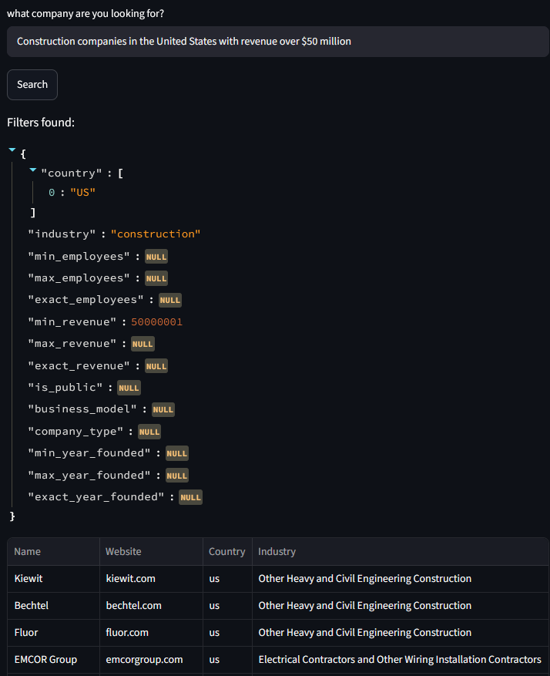

Query 6: "Pharmaceutical companies in Switzerland"
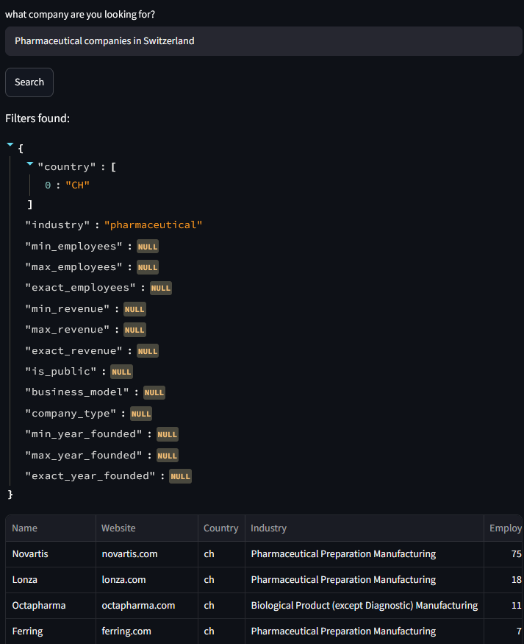

Query 7: "B2B SaaS companies providing HR solutions in Europe"
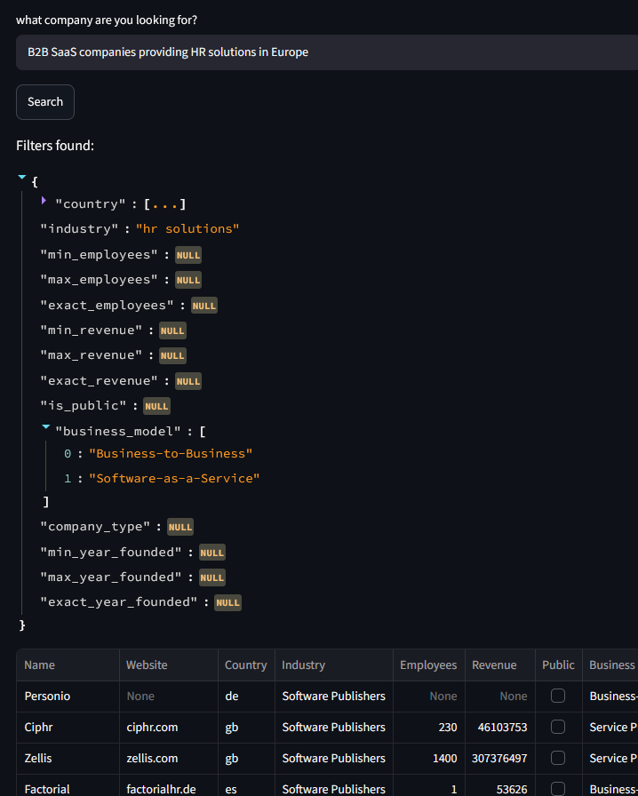

Query 8: "Clean energy startups founded after 2018 with fewer than 200 employees"
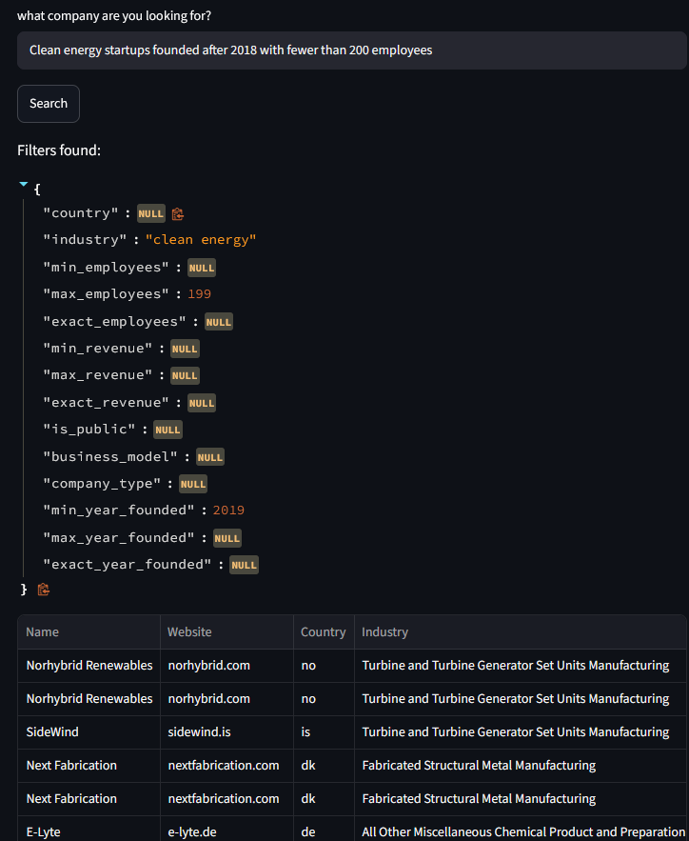

Query 9: "Fast-growing fintech companies competing with traditional banks in Europe"
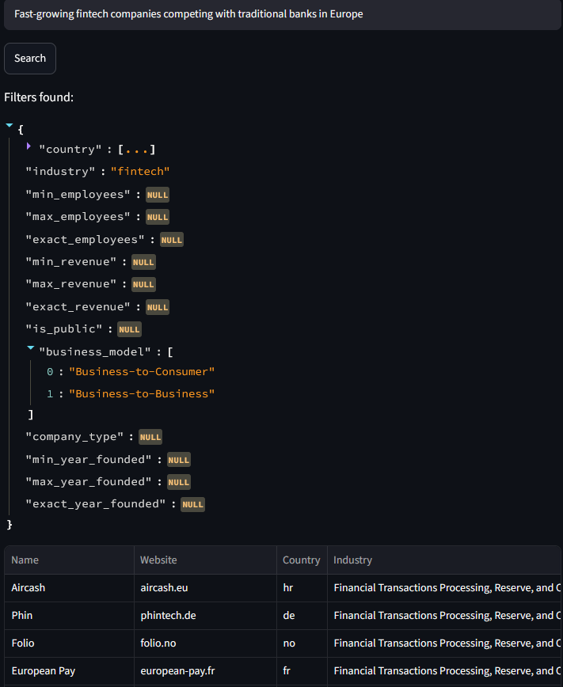

Where it works well and where it does not
The system works well on queries with clear structural constraints. A query like "public software companies with more than 1,000 employees" is essentially a SQL filter: the parser extracts the fields correctly and filtering returns exactly the right candidates. The LLM ranker confirms and refines the order.
Region-based queries also work well. A query mentioning "Scandinavia" automatically receives the corresponding list of ISO codes from the parser, and filtering works correctly without any changes to the filtering logic.
LLM ranking improves results significantly on complex queries compared to embedding similarity. The model understands the difference between a supplier and a client, between a company that produces and one that distributes.
Where the system can go wrong is when structural filters do not cut aggressively enough and the LLM ranker receives a long list. With many companies in the prompt, the model may make ordering errors or exceed the token limit. Descriptions truncated to 200 characters may also not be sufficient to differentiate similar companies.
A clear downside of the application is that it makes two LLM API calls per query. On simple queries where filters cut aggressively, the second call is fast. On vague queries without clear filters, many candidates remain and the ranking call becomes slow and more expensive.
Missing data also introduces a silent problem: a company without an employee count is excluded by any query that specifies a minimum, even if it would otherwise qualify. This conservative approach trades recall for precision.

Scaling
The current implementation loads all companies into memory and filters them in a loop. At 449 companies this works well. At 100,000 companies, two things would break down.
The in-memory company list would need to be replaced with a database: PostgreSQL with indices on country code, employee count, revenue, and year founded. Filters would become SQL WHERE clauses, far more efficient than iterating a Python list.
LLM ranking has a critical limitation at scale: it is not possible to send thousands of companies in a single prompt. At 100,000 companies, structural filtering must cut aggressively before ranking. A hybrid approach would use embedding similarity for a fast pre-filter to top 50 or 100, with the LLM ranking only those.
At large scale, many users would submit similar queries. A cache would store results for identical or very similar queries, significantly reducing LLM API calls.

Failure modes and what I would monitor in production
The most dangerous failure mode is when structural filters do not cut enough and the LLM ranker receives a list that is too long. With hundreds of companies in the prompt, the model can make ordering errors or exceed the token limit. I would monitor the number of companies sent to ranking and set a hard maximum.
The parser can extract incorrect filters from ambiguous queries: a country not mentioned, an overly aggressive revenue filter, or a wrong expansion of a geographic region. In production I would log all extracted JSON objects and monitor for filters that exclude more than 90% of the dataset, filters with all fields null, and country codes that do not exist in the dataset.
Descriptions truncated to 200 characters for ranking may not capture relevant information about a company. A company with a long and relevant description at the end may be ranked incorrectly against one with key information at the start.
Companies with missing data are conservatively excluded by structural filters. I would monitor how many companies are excluded due to missing data versus how many fail the filters on actual values, to understand whether relevant candidates are being lost.

Final notes
The part I found most interesting was the prompt design for the parser. It is surprisingly difficult to write instructions that are both precise enough to produce consistent structured output and flexible enough to handle the full range of query types. I refined the prompt more than any other part of the project.
The decision to replace embedding similarity with direct LLM ranking simplified the code significantly and improved result quality on complex queries. The cost trade-off is real but justified for the current use case.
If I were to continue the project, I would explore a hybrid approach for scalability: embedding similarity for a fast pre-filter to top 50, followed by LLM ranking on those. This would preserve the current ranking quality at a controlled cost and larger scale.

